Bioremediation of Petroleum hydrocarbons
Petroleum pollution has become a serious environmental problem, which can cause harmful damage to the environment and human health. This pollutant is introduced into the environment from both natural and anthropogenic sources. Various physicochemical and biological treatments were developed for the cleanup of contaminated environments. However, bioremediation is based on the metabolic capabilities of microorganisms, and it is considered as the most basic and reliable way to eliminate contaminants, particularly petroleum and its recalcitrant compounds. It is more effective alternative comparing to classical remediation techniques.
A high diversity of potential hydrocarbon degrader’s microorganisms and bacteria constitute the most abundant group for hydrocarbon degradation. Several bioremediation approaches are used such as bioaugmentation or/and biostimulation.
- Introduction
Oil is a primary and necessary energy source, which is widely used in different fields, including industry, transport and daily human activities. However, the widespread distribution and the overexploitation of hydrocarbons become a serious problem causing harmful impacts on the environment and health due to their toxicity and their carcinogenic and mutagenic properties . Hydrocarbon pollution may occur through several sources, natural or anthropogenic.
Anthropogenic sources such as oil extraction and treatment field, transportation fuels accidents, leakage from underground storage tanks, petrochemical industry activities and release from oil refinery sites. To reduce this contamination, different chemical, physical and biological treatment methods are considered.

The choice of remediation methods depends on several parameters. Such as the type of pollutant and its characteristics (the physicochemical nature of the pollutant and its toxicity), the properties of contaminated site (the pollution source, the nature of the site) and the type of the pollution (old or recent). The treatment of a polluted site is carried out only after evaluating the type of pollutant, the environmental and human-associated risks and the treatment feasibility and predicted efficiency.
Bioremediation is considered as one of the best environment-friendly way to remove hydrocarbons presenting several advantages compared to other method.
In fact it is a natural, efficient and economic method. Moreover, it converts hydrocarbon onto less toxic compound through metabolic and enzymatic reactions.
The biodegradation is mainly carried out by bacteria, yeast and fungi. Bacteria represent the major class of microorganisms involved in the degradation of hydrocarbons.
There are two approaches for bioremediation: bioaugmentation and biostimulation.
Bioaugmentation consists in the addition of highly efficient oil-degrading bacteria to improve and enhance the degradation. While biostimulation consists in the modification of the environment conditions in order to stimulate indigenous bacteria activity.
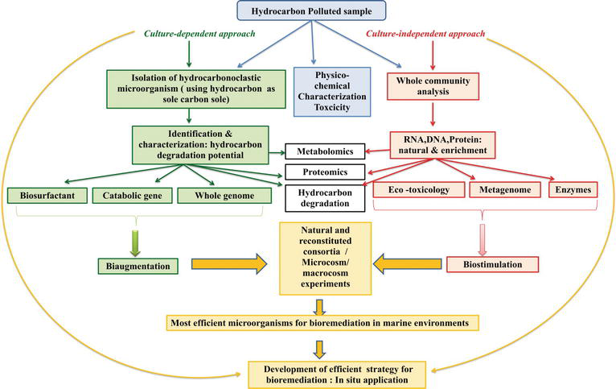

Figure : Schematic diagram explaining the different microbial hydrocarbon degradation strategy for bioremediation

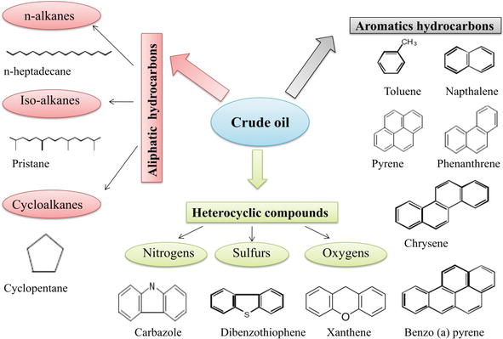

Figure: Different classes of hydrocarbon.

Crude oil is an extremely complex mixture of hydrocarbons (aliphatics and aromatics) and nonhydrocarbons (containing sulfur, nitrogen, oxygen and various trace metals).

Aliphatic hydrocarbons

Aliphatic hydrocarbons are composed of hydrogen and carbon, which are linear, branched or cyclic. Aliphatic compounds can be saturated or unsaturated. There are several types of aliphatic hydrocarbons, including alkanes, alkenes and alkynes. Alkanes are the most abundant constituents in crude oil and are the first component that are degraded.

Aromatic hydrocarbons
Polycyclic aromatic hydrocarbons (PAHs) are a group of approximately 10,000 compounds that are atmospheric, water and soil pollutants containing one or more aromatic rings. Due to their complex structure, PAHs are highly resistant to degradation and remain persistent in the ecosystem.

Heterocyclic compounds

Heterocyclic compounds are organic compounds containing at least one heterocyclic ring. They consist of compounds in which common heteroatoms are incorporated (oxygen, nitrogen and sulfur) into an organic ring structure in place of a carbon atom. They include polar compounds such as nitrogen (quinolines), sulfur (dibenzothiophenes) and oxygen (xanthene) atoms. Heterocyclic compounds are the most recalcitrant for degradation.

Hydrocarbon bioremediation: bioaugmentation, biostimulation \

and landfarming
Due to their high environmental and health-associated hazards, several physical and chemical hydrocarbon treatment methods used such as incineration, chlorination, UV oxidation and solvent extraction . However, most of these approaches are associated to several drawbacks in terms of ecological impact and of removal efficiency.
In the meanwhile, the biological approach are great interest for hydrocarbon removal.
- phytoremediation strategy that uses plants for decontamination purposes and (b) bioremediation that involves the use of microbial
- population for the cleanup of contaminated sites.
Bioremediation is considered as a tool for the decontamination of hydrocarbon polluted sites and as an extremely effective approach associated to eco-friendly features and relatively low cost. It is also considered as a safe approach. It is based on the catabolic activities of microorganisms and their ability to use pollutant as carbon and energy source by transforming it into less or non-toxic compounds.

Different bioremediation strategies are used depending on several factors such as site characteristics, type and concentration of pollutants . Bioremediation can either be carried out ex situ or in situ.
Ex situ methods involve the physical removal of the contaminated land for treatment process.
However, in situ techniques involve treatment of the contaminated material in place .
The bioremediation efficiency depends mainly on the microbial structure, the sites to be decontaminated and the environmental conditions. These factors influence the degradation rate and the microbial activity. Moreover, bioremediation efficiency can be enhanced by three complementary approaches: bioaugmentation, biostimulation and landfarming.

Bioaugmentation
Bioaugmentation consists in the addition of selected microbial species, harboring specific catabolic abilities, into a contaminated environment. However, this technique involves the application of allochthonous or autochthonous microorganisms. The autochthonous bioaugmentation (ABA) consists on the exclusive introduction of indigenous microorganisms to the sites to be decontaminated . As described in Figure, the bioaugmentation treatment where A is related to the cultivation of bacteria and/or consortium with high biodegradative capability in laboratory; B showed the addition on natural polluted environment; Cs explain the attack of bacteria and/or microbial consortium selected of pollutant (crude oil and/or hydrocarbons) and D showed the development of biodegradative process.

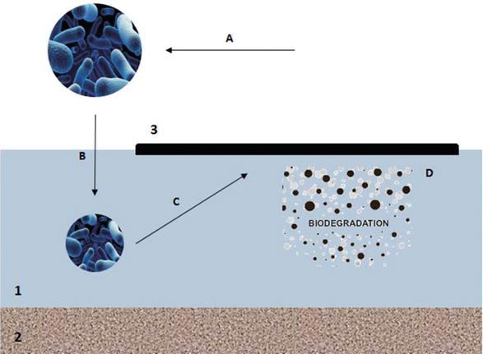
Schematic description of bioremediation (bioaugmentation) process. 1: Seawater; 2: marine sediment; 3: crude oil.
The ABA approach consists on the addition of autochthonous microbial isolates or consortia that are adapted to the contaminated environments.The efficiency of autochthonous microorganisms in the decontamination of hydrocarbon-polluted sites based on the fact that environmental conditions are suitable for their growth and metabolism . They significantly contribute to the biochemical activities in soil.

Allochthonous microorganisms are defined as non-indigenous and originated from other site. When they are added into contaminated sites, they cannot easily integrate and adapt to the activities of the indigenous microbial community. Generally, Bioaugmentation is performed by using mixed consortia.
For a successful bioaugmentation treatment, environmental conditions, selected and indigenous microorganisms should be well controlled and characterized.

Biostimulation
Biostimulation consists in the addition of different substance to polluted environments to stimulate the natural biodegradation by indigenous
degrading microorganisms. The biodegradation of hydrocarbons in marine environment is limited by low oxygen and nutriment availability, more specifically nitrogen and phosphorous . The low bioavailability of pollutants is also considered as a limiting factor . The biostimulation increases the growth of indigenous hydrocarbon degraders by the addition of growth-limiting nutrients. Moreover, the addition of specific substrate promotes and stimulates the degradation of the pollutant.
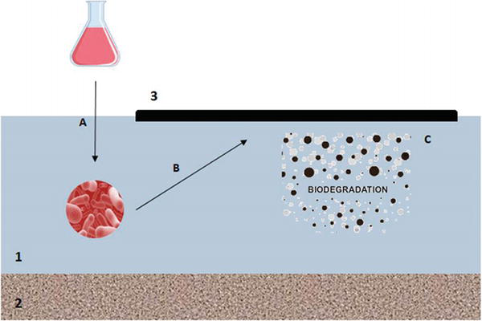

Figure

Schematic description of bioremediation (biostimulation) process. 1: Seawater; 2: marine sediment; 3: crude oil.

Landfarming
Landfarming is a bioremediation approach, also known as land treatment or land application. This biotreatment process involves the spreading of excavated contaminated soils or sediments in a thin layer on a suitably prepared surface. In addition, the stimulation of the microbial activity in the soil is performed through the aeration and/or the addition of minerals and nutrients. Thus, the incorporated contaminated soil is periodically turned over or tilled to aerate the mixture. Landfarming presents various advantages comparing to other treatment technologies. It has low cost, energy consumption and simple to implement. It is used for the remediation of hydrocarbon-contaminated soils.

